Leaf Health Checker
AI Plant Disease Detection System

Team ID: SWTID-2026-7731
Team Leader: SHUBAVARDHANA M(3DE3A7B6A9D733F94CB4D7E43746719C)
Team Member: THARUNKUMAR N V(9ACEC547ACAFE15915B44DF58E025E3E)
Team Member: STEPHEN RAJ G(6B97335CED604C3BABE418E94FA41551)
Team Member: WILSON S(2645663D618725A8DE04388740656112)

Project Description
Plant health monitoring plays a critical role in agriculture, gardening, and environmental sustainability. Traditionally, identifying plant diseases requires manual inspection by experts, which can be time-consuming and often inaccurate. Early symptoms such as yellowing, discoloration, and leaf spots are sometimes overlooked, leading to serious crop damage and reduced productivity.
Leaf Health Checker AI is an intelligent plant disease detection system designed to analyze plant leaf images using artificial intelligence and computer vision techniques. The system allows users to upload an image of a plant leaf through a web interface and receive an instant health diagnosis.
The application is developed using the Streamlit framework and integrates image processing, deep learning models, and AI analysis to detect plant diseases. The uploaded leaf image is preprocessed using image enhancement techniques and analyzed to identify discoloration patterns such as yellow, brown, or black spots.
The AI model then predicts the plant species and identifies possible diseases affecting the plant. Based on the level of discoloration and damage percentage, the system classifies the leaf condition into severity levels such as Healthy, Mild, Moderate, Severe, or Dying.
In addition to diagnosis, the system also generates three intelligent rescue recommendations that guide users on how to treat the plant. These suggestions may include improving watering schedules, applying fertilizers, adjusting sunlight exposure, or using disease treatments.
By combining AI technology with an easy-to-use interface, Leaf Health AI provides a fast, accurate, and accessible solution for plant health monitoring, helping farmers, students, and gardening enthusiasts detect plant diseases early and take corrective actions.

Use Case Scenarios
Scenario 1: Leaf Image Upload and Health Analysis
A user uploads an image of a plant leaf through the Streamlit web interface. The system preprocesses the image by resizing it, normalizing pixel values, and removing noise. The AI model then analyzes the image to detect discoloration patterns and determine whether the leaf is healthy or infected.
The result is displayed with the predicted disease, severity level, and confidence score.

Scenario 2: Plant Species Identification and Disease Detection
After the image is uploaded, the system compares the leaf image with the plant species database. Once the plant type is identified, the system predicts diseases commonly associated with that species. This ensures more accurate and plant-specific disease diagnosis.

Scenario 3: Severity Detection and Rescue Recommendations
Based on the percentage of discoloration and disease probability, the system calculates the severity level of the leaf condition. It then generates three personalized rescue tips that guide users in improving plant health and preventing further damage.

Architecture Overview
Leaf Health AI is a smart plant disease detection platform designed to analyze plant leaf images and provide accurate health diagnosis with treatment suggestions. The system integrates Streamlit UI, AI models, image processing modules, and a recommendation engine to deliver real-time results.
The application processes uploaded leaf images, performs image analysis, predicts plant disease, determines severity level, and generates rescue recommendations for users.

Core Technologies
- Streamlit: Interactive web framework used to build the frontend interface for uploading leaf images and displaying results.
- Python 3.10: Backend programming language used for AI integration, image processing, and application logic.
- TensorFlow / PyTorch: Deep learning frameworks used to train and run plant disease classification models.
- OpenCV: Used for image preprocessing, noise reduction, and discoloration detection.
- NumPy & Pandas: Used for data processing and numerical analysis.
- SQLite Database: Stores plant species information and disease data.
- PIL (Python Imaging Library): Handles image loading and visualization.
- Google Gemini AI (Optional): Used for enhanced diagnosis generation and intelligent recommendations.

Component-Wise Architecture
Component | Description
Frontend UI | Streamlit-based interface that allows users to upload plant leaf images and view diagnosis results.
Image Processing Module | Performs resizing, normalization, RGB conversion, and noise removal for accurate analysis.
AI Model Layer | Deep learning model that identifies plant species and predicts plant diseases with confidence score.
Severity Grading Engine | Calculates percentage of affected area and classifies leaf condition (Healthy, Mild, Moderate, Severe, Dying).
Species Database | Stores plant species data and disease information for accurate diagnosis.
Recommendation Engine | Generates three personalized rescue tips based on disease type and severity level.
Export Module | Allows users to download diagnosis reports in text or PDF format.

System Workflow
- User uploads leaf image through Streamlit interface
- Image preprocessing (resize, normalize, noise reduction)
- Discoloration detection (yellow/brown pixel percentage analysis)
- AI model predicts:
  - Plant species
  - Disease class
  - Confidence score
- Severity grading is calculated
- Rescue tips are retrieved from database
- Final diagnosis report is displayed

Severity Grading Logic
- 0–10% Discoloration → Healthy
- 11–30% → Mild
- 31–60% → Moderate
- 61–80% → Severe
- 81–100% → Dying
Severity is calculated based on:
- Percentage of yellow/brown regions
- Disease probability score
- Leaf texture damage

Output Format
Diagnosis Report
Plant Name: <Identified Plant>
Disease: <Predicted Disease>
Confidence Score: <Model Accuracy %>
Severity Level: <Health Grade>
Rescue Tips:
- <Tip 1>
- <Tip 2>
- <Tip 3>

Deployment Architecture (Streamlit Based)
User → Streamlit UI → Image Processing → AI Model → Severity Engine → Recommendation Engine → Output Display
The application can be deployed on:
- Streamlit Cloud
- AWS / Azure
- Local Server

Pre-requisites
- Python 3.10 or above
- Streamlit Framework
- TensorFlow or PyTorch
- OpenCV Library
- Required Python Libraries (requirements.txt)
- Internet connection (for Gemini AI integration)
- Minimum 4GB RAM
Example installation:
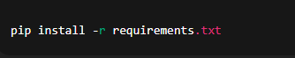
Run the application:
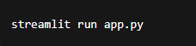

Project Workflow
The Leaf Health AI system follows a structured development workflow consisting of five milestones,
1. AI Model Setup & Initialization

Activity 1.1: Setup Deep Learning Environment
- Install Python and required AI libraries
- Configure TensorFlow / PyTorch environment
- Download plant leaf disease dataset
- Verify GPU/CPU compatibility for model training

Activity 1.2: Configure Environment and Dependencies
- Create virtual environment
- Install required packages using requirements.txt
- Configure model loading paths
- Setup image preprocessing configurations

Activity 1.3: Prepare Detection Logic
- Design discoloration detection algorithm
- Define yellow and brown color thresholds
- Prepare plant species classification labels
- Test preprocessing with sample leaf images

2. Core Functionality Development

Activity 2.1: Design Streamlit Application Structure
- Create main Streamlit interface (app.py)
- Build modular folder structure
- Implement navigation and layout components
- Configure session state handling

Activity 2.2: Implement Image Upload Module
- Upload JPG/PNG leaf images
- Validate image size and format
- Display preview of uploaded image
- Add loading indicator during analysis

Activity 2.3: Develop AI Prediction Pipeline
- Perform image preprocessing
- Run species identification model
- Detect disease class
- Calculate prediction confidence score
3. Backend Processing Implementation

Activity 3.1: Image Processing Module
- Resize and normalize images
- Convert images to RGB format
- Remove noise using filtering
- Extract discoloration regions using OpenCV

Activity 3.2: Severity Grading Engine
- Calculate percentage of affected pixels
- Apply grading logic:
  - Healthy
  - Mild
  - Moderate
  - Severe
  - Dying
- Combine discoloration + AI prediction results

Activity 3.3: Species Database Integration
- Create plant species database
- Map detected species with diseases
- Store treatment and care information
- Retrieve matching plant details
Activity 3.4: Recommendation Engine
- Generate rescue tips based on disease
- Adjust tips according to severity level
- Ensure minimum three actionable suggestions

4. UI Development (Streamlit)

Activity 4.1: Build Interactive Interface
- Application title and description
- Image upload widget
- Analyze button
- Progress spinner during processing
Activity 4.2: Implement Result Display
- Show detected plant species
- Display disease diagnosis
- Show severity badge
- Display confidence percentage
- Present rescue tips clearly

Activity 4.3: Add Export Functionality (Optional)
- Generate downloadable diagnosis report
- PDF export option
- File naming and download handling

5. Testing & Optimization

Activity 5.1: Functional Testing
- Test with multiple plant species images
- Validate discoloration detection
- Verify severity grading accuracy
- Check UI responsiveness

Activity 5.2: Model Evaluation
- Measure prediction accuracy
- Validate classification confidence
- Reduce false predictions
- Improve preprocessing quality

Activity 5.3: Performance Optimization
- Optimize image processing speed
- Reduce model loading time
- Improve Streamlit responsiveness
- Handle invalid or low-quality inputs

Activity 5.4: Deployment Readiness
- Prepare requirements.txt
- Configure Streamlit Cloud deployment
- Test application in production environment
- Ensure cross-platform compatibility

MILESTONE 1: Gemini AI Initialization
MILESTONE 1: AI Model Initialization
In this foundational stage, the objective is to establish and configure the core AI infrastructure required for the Leaf Health Check system. The platform utilizes a deep learning–based computer vision model to analyze plant leaf images, detect discoloration patterns, identify plant species, and generate health diagnosis with rescue recommendations.
Activity 1.1: Setup Development Environment and AI Mode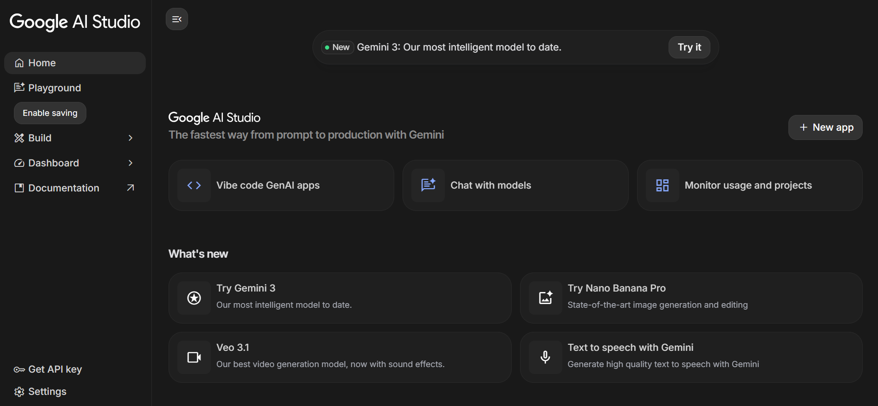
1. Install Required Software
- Install Python (version 3.8 or above)
- Install required IDE (VS Code / PyCharm)
- Setup virtual environment for project isolation
2. Install Required Libraries
3. Prepare AI Model
- Download plant leaf disease dataset
- Configure trained CNN model (TensorFlow/PyTorch)
- Store trained model file inside /model directory
- Verify model loading functionality
Activity 1.2: Configure Environment and Test Setup
1. Create. env File
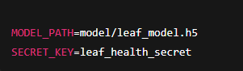

2. Load Environment Variables
Example configuration code:
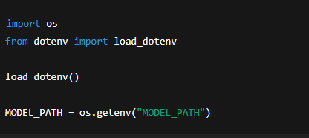
3. Test Model Loading
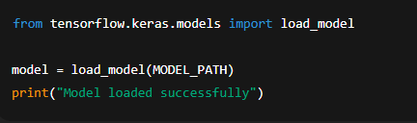
Expected Result:
- Model loads without errors
- Ready for prediction testing

Activity 1.3: Validate Image Processing and Prediction

Test Image Preprocessing
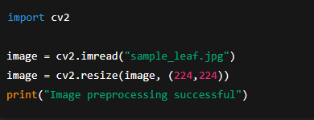

Test Disease Prediction
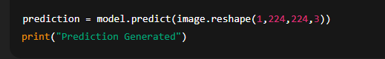
Expected Output:
- Model predicts plant disease class
- Confidence score generated successfully

MILESTONE 2: Core Functionalities Development
This milestone focuses on building the core application using the Streamlit framework integrated with the Google Gemini API. The system accepts plant leaf images, processes visual information, analyzes discoloration patterns, and generates an AI-based diagnosis with severity grading and rescue recommendations.

File Explorer Structure
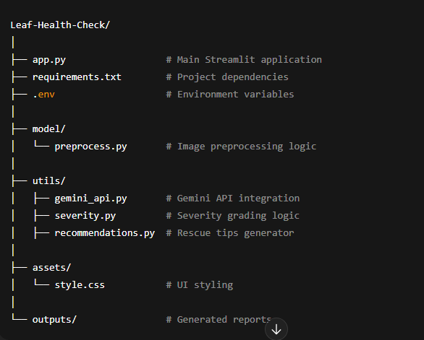

Activity 2.1: Streamlit Initialization and Import Libraries
Import Required Libraries
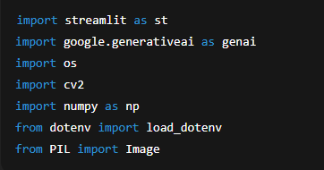

Initialize Environment and Gemini API
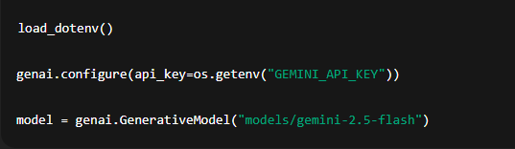

Activity 2.2: Main Functionality – Leaf Analysis Routing

Image Upload Interface
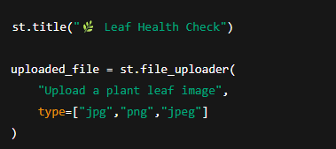

Image Processing
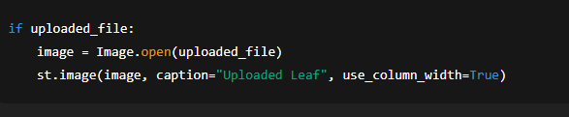

Gemini AI Diagnosis Request
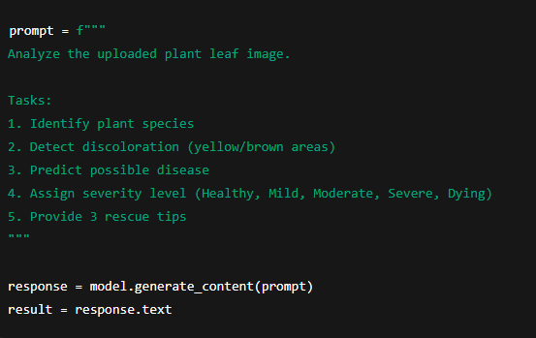

Display Result
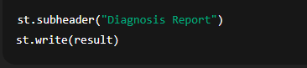

Activity 2.3: Severity Grading Logic
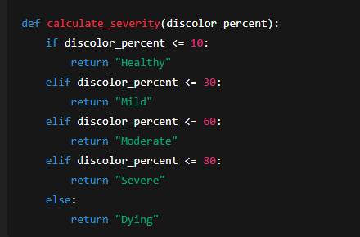

Activity 2.4: Export Functionality

Generate Text Report
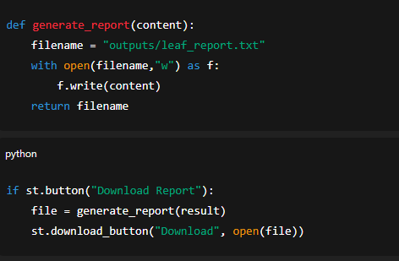

Activity 2.5: Utility Functions

Clean AI Response
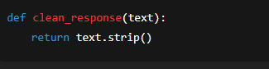

Unique File Generator
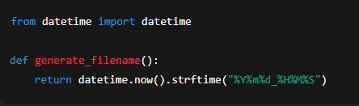

MILESTONE 3: Backend – Streamlit Integration (app.py)
This milestone focuses on implementing the complete backend logic inside the Streamlit application, integrating the Google Gemini AI Studio API, handling image processing, performing diagnosis generation, and enabling export functionality. The system ensures proper validation, structured responses, and smooth interaction between the UI and AI services.
Activity 3.1: Complete Function Definitions
All backend processing is implemented with:
- Input image validation
- Error handling mechanisms
- Gemini API response handling
- Logging and debugging support
- Structured diagnosis output formatting
Image Validation Example
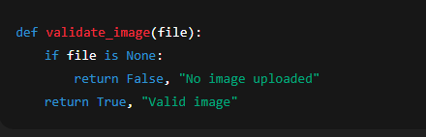

Activity 3.2: Modular Architecture
Main Application Structure
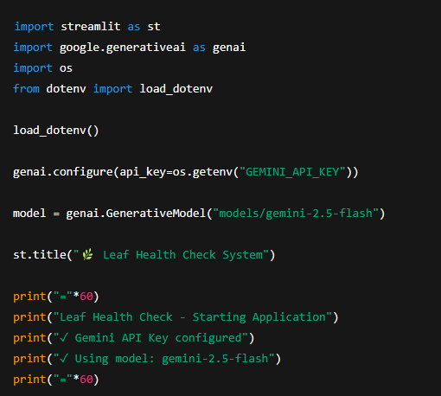
The Streamlit application directly manages:
- User interaction
- AI communication
- Diagnosis generation
- Result visualization

Activity 3.3: Gemini AI Diagnosis Integration

Generate Diagnosis from Image
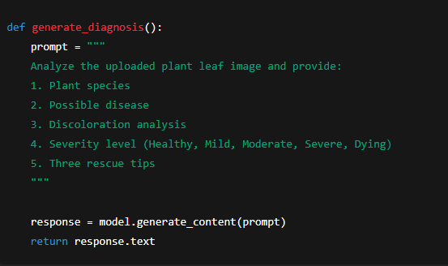

Display AI Response
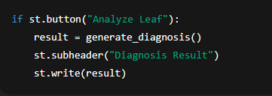
Activity 3.4: Export Implementation
Complete export functionality includes:
- Diagnosis report generation
- Downloadable text/PDF report
- File management and naming
Report Generation
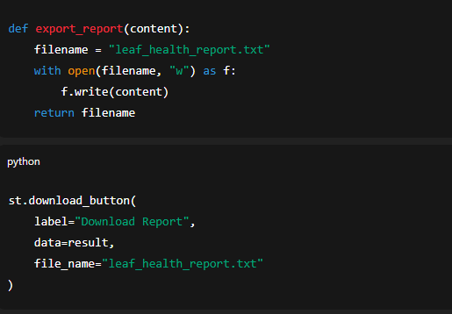
Activity 3.5: Error Handling and Response Formatting
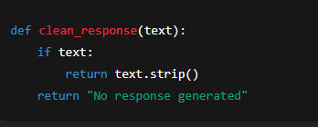

MILESTONE 4: UI Development
This milestone focuses on designing and implementing a user-friendly and responsive interface for the Leaf Health Check application using the Streamlit framework. The UI ensures smooth interaction between the user and the AI system, enabling easy image upload, analysis execution, and result visualization.
Activity 4.1: Home Page Development
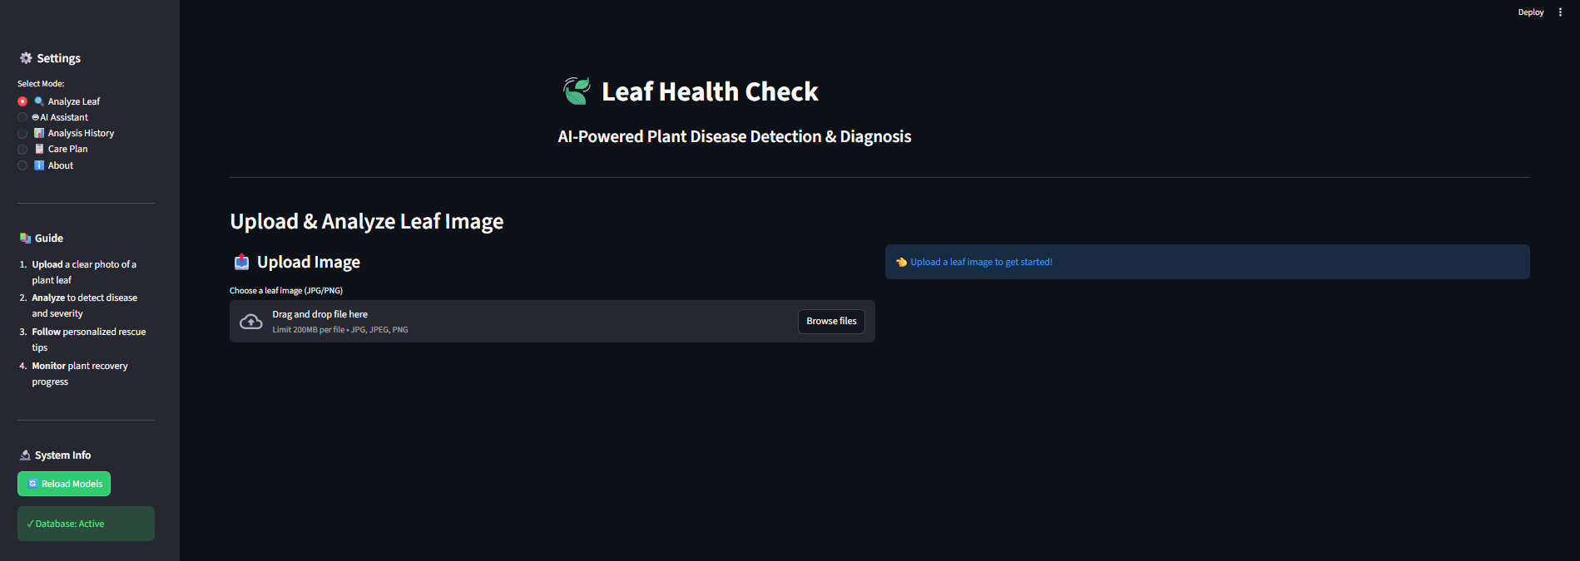
The home page acts as the primary interface for user interaction and provides clear guidance on how to use the application.
Home Page Features:
- Application title and description
- Leaf image upload section
- Supported image format information
- Analyze button for triggering diagnosis
- Clean and responsive layout
UI Design Considerations:
- Simple and minimal design
- Clear instructions for users
- Responsive layout across screen sizes
- Intuitive navigation flow

Activity 4.2: Leaf Analysis Page
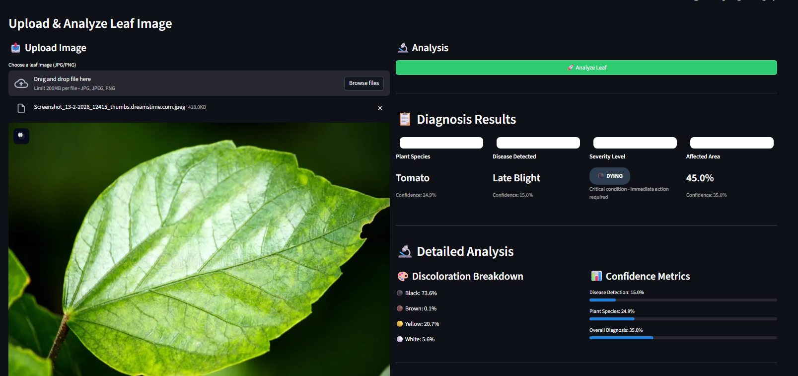
This section handles user input and displays AI-generated results after analysis.
Features Implemented:
- Image preview after upload
- Loading spinner during analysis
- Gemini AI diagnosis display
- Plant species identification
- Disease detection result
- Severity grading badge
Severity Levels Displayed:
- Healthy
- Mild
- Moderate
- Severe
- Dying

Activity 4.3: Rescue Recommendation Display
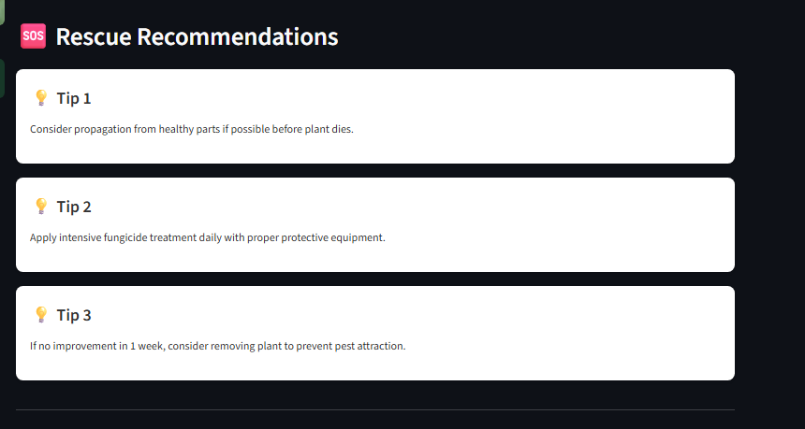
After diagnosis, the system presents actionable rescue recommendations to help users treat the affected plant.

Rescue Tips Section Includes:
- Three personalized rescue tips
- Tips based on disease type and severity
- Easy-to-read bullet format
- Practical and actionable suggestions

Activity 4.4: Result Export Option
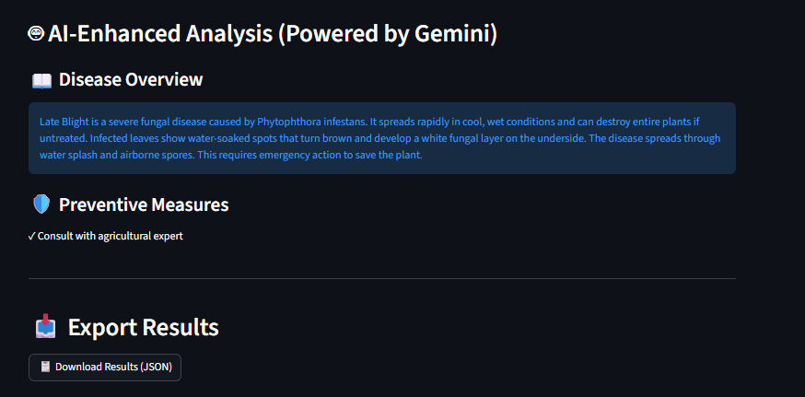
To enhance usability, the UI provides an option to download the diagnosis report.
Export Features:
- Download diagnosis as a text/PDF report
- Automatically generated report name
- Includes plant name, disease, severity, and tips

Activity 4.5: Error Handling and User Feedback
Proper feedback mechanisms are integrated to improve user experience.
Handled Scenarios:
- Invalid image format
- No image uploaded
- AI response failure
- Low-quality image warning
Feedback Methods:
- Warning messages
- Error alerts
- Success notifications

MILESTONE 5: Testing & Optimization
This milestone focuses on comprehensive testing, quality evaluation, and performance optimization of the Leaf Health Check application to ensure accuracy, reliability, and smooth user experience. Multiple test scenarios were executed to validate image analysis, AI diagnosis, severity grading, and rescue recommendations.

Activity 5.1: Comprehensive Testing

Test Scenarios
1. Leaf Image Analysis
- Input Type: Plant leaf images
- Formats Tested: JPG, PNG, JPEG
- Conditions: Healthy, diseased, partially damaged leaves
- Expected Output: Accurate diagnosis with severity grading and rescue tips
Test Cases Executed:
- Healthy green leaf image
- Yellowing leaf image
- Brown spot infected leaf
- Severely damaged leaf image
- Low-quality and blurred images

2. Discoloration Detection
- Colors Tested: Yellow, brown, black
- Severity Levels Verified: Healthy, Mild, Moderate, Severe, Dying
- Expected Result: Correct severity classification based on affected area

3. Gemini AI Diagnosis Testing
- API Used: Gemini AI Studio API Key
- Model Tested: Gemini Vision Model
- Expected Output:
  - Plant species identification
  - Disease prediction
  - Confidence-based severity grading
  - Three actionable rescue tips

4. Error Handling Scenarios
- No image uploaded
- Unsupported image format
- Corrupted image file
- API response delay or failure
Expected Behavior:
- User-friendly error messages
- Graceful failure handling
- No application crash

Activity 5.2: Quality Evaluation

The output quality of the system was evaluated using the following metrics:
- Diagnosis Accuracy
- Severity Classification Correctness
- Relevance of Rescue Tips
- Response Consistency
- User Interface Clarity
- Report Export Quality
Each test output was manually reviewed to ensure logical correctness and practical usefulness.

Activity 5.3: Performance Optimization

Improvements Made
- Faster image preprocessing using optimized resizing
- Reduced Gemini API response latency
- Improved input validation logic
- Optimized Streamlit layout rendering
- Added loading indicators for better user feedback
- Reduced unnecessary re-computation using session state

Activity 5.4: Final Validation

After optimization, the system was re-tested to confirm:
- Stable application performance
- Accurate AI predictions
- Correct severity grading
- Smooth UI interaction
- Successful report downloads

Conclusion
Leaf Health AI demonstrates the practical application of artificial intelligence in modern agriculture. By integrating image processing, deep learning models, and an interactive Streamlit interface, the system enables quick and accurate plant disease detection using simple leaf images.
The platform helps users identify plant diseases early, determine severity levels, and receive practical rescue recommendations. This reduces the dependency on manual inspection and expert consultation.
Overall, the project provides a smart, accessible, and efficient solution for plant health monitoring, contributing to sustainable agriculture and improved crop productivity.

